Equality Impact Assessment (EqIA) November 2018

You will need to produce an Equality Impact Assessment (EqIA) if:

- You are developing a new policy, strategy, or service
- You are making changes that will affect front-line services
- You are reducing budgets, which may affect front-line services
- You are changing the way services are funded and this may impact the quality of the service and who can access it
- You are making a decision that could have a different impact on different groups of people
- You are making staff redundant or changing their roles

Guidance notes on how to complete an EqIA and sign off process are available on the Hub under Equality and Diversity.
You must read the guidance notes and ensure you have followed all stages of the EqIA approval process (outlined in appendix 1).
Section 2 of the template requires you to undertake an assessment of the impact of your proposals on groups with protected characteristics. Equalities and borough profile data, as well as other sources of statistical information can be found on the Harrow hub, within the section entitled: Equality Impact Assessment - sources of statistical information.

Equality Impact Assessment (EqIA)

Type of Decision:
Title of Proposal | reducing fly tipping and littering strategy | Date EqIA created 30 03 2023
Name and job title of completing/lead Officer | Emma Phasey Head of Licensing and Enforcement

Directorate/ Service responsible
Organisational approval
EqIA approved by the EDI Team | Name: Jennifer Rock  Assistant Policy Officer  EDI Team | Signature  ☒  Tick this box to indicate that you have approved this EqIA  Date of approval 05/04/23

- Summary of proposal, impact on groups with protected characteristics and mitigating actions
(to be completed after you have completed sections 2 - 5)
- What is your proposal?
This report seeks approval to adopt a new strategy to tackle and reduce instances of fly tipping and littering in the Borough.
The main strands of focus within the strategy to enable the delivery of improvements are:
- Early intervention – education, communication and engagement
- Prevent reoccurrence –Holistic action plans for hotspot areas
- Targeted enforcement – Intelligence lead appropriate enforcement action
It focuses on increased enforcement and compliance work at the same time as an increase in communications to residents and the public that fly tipping is an environmental crime and socially unacceptable.

- Summarise the impact of your proposal on groups with protected characteristics
The recommendations in the report will apply to and benefit all households and all residents in Harrow and it is therefore considered that there will be no negative impact on any protected characteristics.

- Summarise any potential negative impact(s) identified and mitigating actions
None

2. Assessing impact
You are required to undertake a detailed analysis of the impact of your proposals on groups with protected characteristics. You should refer to borough profile data, equalities data, service user information, consultation responses and any other relevant data/evidence to help you assess and explain what impact (if any) your proposal(s) will have on each group. Where there are gaps in data, you should state this in the boxes below and what action (if any), you will take to address this in the future. |  | What does the evidence tell you about the impact your proposal may have on groups with protected characteristics? Click the relevant box to indicate whether your proposal will have a positive impact, negative (minor, major), or no impact
Protected characteristic | For each protected characteristic, explain in detail what the evidence is suggesting and the impact of your proposal (if any). Click the appropriate box on the right to indicate the outcome of your analysis. | Positive impact | Negative  impact |  | No impact
 |  |  | Minor | Major
Age | Harrow has a resident population of 251,160. It has an above average working age population aged 16-64 of just under 63% (158,000) and a growing younger population aged 0-15, which is higher than the London average, suggesting that the borough is a popular destination for families  The proposal will:  Ensure that the streets are clear and clean for persons of all ages by encouraging residents not to fly tip and taking swift enforcement action against those who do.  Currently the majority of FPNS for littering are for the dropping of cigarette butts which means these is likely to be over 18s.  We cannot break down out FPN data by offence type but overall we know that the following age groups are served the largest percentage of FPNS  20-29 20.93%  30-39 25.35%  40-49 17.30%  Not known 22.23% | ☐ | ☐ | ☐ | ☒
Disability | - ONS data for 2016-2018 shows that 19,208, (12.2%) of Harrow’s working age population have a disability.  - There is a strong correlation between disability, in particular the extent of the disability, and economic inactivity.  - There are also particular groups that have specific obstacles in progressing to the labour market. These include adults with learning disabilities and those with severe mental health issues.  - Accessibility and suitable transport are also barriers for disabled people.  - Disabled people are also likely to be under-represented among business owners within Harrow.  The proposal will:  Ensure that the streets are clear and clean for all persons.  It is unlikely that the proposal will lead to differential impact for people based on this protected characteristic  Keeping the streets clear and clean is likely to positively impact on those with disabilities affecting eyesight or mobility as it should reduce the amount of obstacles on the pavement | ☒ | ☐ | ☐ | ☒
Gender  reassignment | - There is limited national data collected for this characteristic. We will need to consider the inequalities and discrimination experienced for this protected group when data becomes available.  - The charity GIRES estimated in their Home Office funded study in 2009 the number of transgender people in the UK to be between 300,000 and 500,000. More recently Stonewall advised that it is estimated that around 1% of the population might identify as trans, including people who identify as non-binary. This would represent about 600,000 trans and non-binary people in Britain and about 2,500 people in Harrow.  The proposal will:  Ensure that the streets are clear and clean for all persons.  It is unlikely that the proposal will lead to differential impact for people based on this protected characteristic | ☐ | ☐ | ☐ | ☒
Marriage and Civil Partnership | l At the time of the 2011 Census 54% of Harrow's residents were married, which was the highest level in London. 21% of households were married, or in same-sex civil partnerships, with dependent children, the highest level in London. At October 2020 there have been 144 Same Gender Civil Partnerships in Harrow, 25 of which has been converted to a Marriage. There have been 8 Opposite Gender Civil Partnerships. There have been 57 Same Sex marriages.  The proposal will:  Ensure that the streets are clear and clean for all persons res.  It is unlikely that the proposal will lead to differential impact for people based on this protected characteristic dents at 2011 Census | ☐ | ☐ | ☐ | ☒
Pregnancy and Maternity | - ONS births figures show Harrow as having 3,526 live births in 2019. 14 live births per 1000 population is higher than the England & Wales average of 10.8  - The borough has the worst infant mortality rate in London, at a rate of 5.1 deaths per 1000 live births, which is a strong indicator of poverty and inequality in the borough.  - Nationally, women have faced discrimination during pregnancy and maternity in the workplace. EHRC Survey data shows that around one in nine mothers (11%) reported that they were either dismissed; made compulsorily redundant, where others in their workplace were not.  The proposal will:  Ensure that the streets are clear and clean for all persons.  It is unlikely that the proposal will lead to differential impact for people based on this protected characteristic | ☐ | ☐ | ☐ | ☒
Race/  Ethnicity | 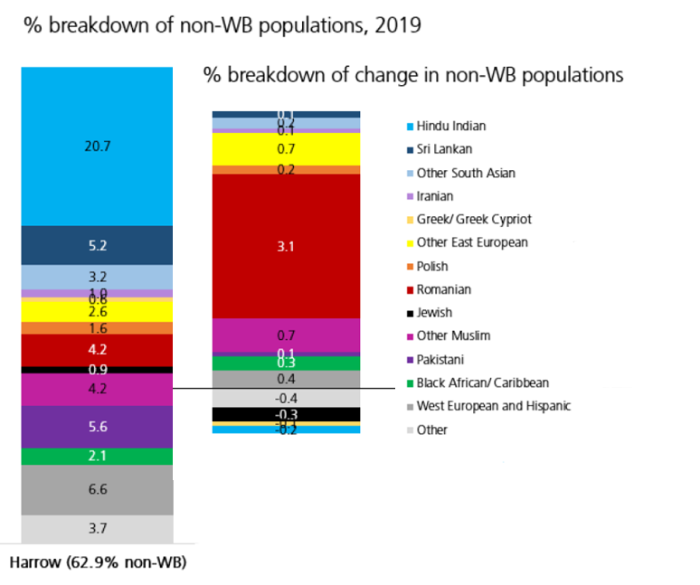  - Harrow is one of the most culturally diverse local authorities in the UK, with over 60% of residents from Black, Asian, and Multi-Ethnic backgrounds and an estimated 20% Eastern European community, which is fast growing. Black African (notably the Somali Community) groups have been fast growing over the last 6 years or so, as has the Afghan community.  - Unemployment rates are significantly higher in certain areas of the borough, particularly in the Wealdstone and Marlborough wards (central Harrow) and  - Roxbourne (south Harrow), focused in an around the Rayners Lane estate and among residents classified as Black and Other ethnic groups. These areas are also ranked high on the indices of deprivation for the UK.  - The majority of 16–18-year-olds that are classed as NEET are from Black and Multi Ethnic backgrounds and located in wards with high levels of deprivation. However, the data also shows that the single largest ethnic group of pupils aged 16-18 classed as NEET is White British.  - At ward level Marlborough, and Wealdstone have the highest number of households in need of re-housing. These respectively have a Black and Multi Ethnic population of 77% and 75%.  - The highest rates of overcrowding is in Greenhill ward (97.5 per 1,000 households) and a Black and Multi Ethnic population of 74% (2011 census).  - Over 94% of Harrow businesses are classed as micro-businesses. There is limited data on the profile of business ownership by protected characteristics. Anecdotal evidence suggests that most retail businesses in Harrow’s town centres are Black and Multi Ethnic - owned.  The proposal will:  Ensure that the streets are clear and clean for all persons.  It is unlikely that the proposal will lead to differential impact for people based on this protected characteristic.  The evidence that we have suggests the areas most suceptiple to fly tip are often the more deprived areas in the Borrough which may have higher than average Black and Multi Ethnic population therefore tackling fly tip with this strategy will have a positive impact on these communities.  Communications around this strategy will be made as pictorial as possible to reduce the barrier of language. Targeted communication will also be transmitted into the appropriate language where appropriate. | ☒ | ☐ | ☐ | ☒
Religion or belief | - Religious diversity is strong in Harrow. At the 2011 Census Harrow was the most religiously diverse borough in the country. Harrow had the highest number (and proportion) of Hindu followers in the country (25.3%), the highest number of Jains (2.2%) and the second highest number of Zoroastrians. Harrow 's Jewish community was the sixth largest nationally. 37.3% of residents were Christians (the 5th lowest proportion in the country) and 12.5% were Muslims. Harrow had the 2nd lowest ranking for ‘no religion’.  - As the population’s ethnic composition changes, rates of participation in various religions are also likely to change.  - There is limited data on employment/unemployment rates for Harrow by religion.  - Data for London suggests that educational attainment and employment among the capital’s Muslim community is lower than those from other faith groups located in the borough.  The proposal will:  Ensure that the streets are clear and clean for all persons.  . It is unlikely that the proposal will lead to differential impact for people based on this protected characteristic | ☐ | ☐ | ☐ | ☒
Sex | - The Government’s population estimates as of mid-2019 show that the total population of Harrow is now 251,200, made up of 125,800 men and 125,400 women. Overall, the number of males and females living in Harrow is very similar.  - Economic activity among Harrow’s male population is higher than the London average at 86%, compared with 83%. However, economic activity among females in the borough is lower than the London average at 72%.  - Harrow is a low wage borough, with both men and women that are employed in the borough earning less than the London average of £760earning less compared to men. Women earn less than men in the borough. Average gross weekly earnings among women working in Harrow is £500, nearly 38% lower than the London average of £688.  - 20% of Harrow businesses are female led.  - While the pandemic may have negatively impacted both sexes, the shift to home working may have had a positive impact in enabling women ton return to work, as they are able to share childcare responsibilities.  The proposal will:  Ensure that the streets are clear and clean for all persons.  . It is unlikely that the proposal will lead to differential impact for people based on this protected characteristic  We cannot break down out FPN data by offence type but overall we know FPNS served by sex are:  Females 13.61%  Male 86.39%  Therefore the residents we will be seeking communicate with to improve compliance will be males | ☐ | ☐ | ☐ | ☒
Sexual Orientation | - The Office for National Statistics estimated in 2014, 2.6% of Londoners identify as lesbian, gay, or bisexual, the highest of any UK region. There is no official data on sexual orientation for Harrow in relation to employment.  - LGBT people are also likely to be underrepresented among business owners within Harrow.  The proposal will:  Ensure that the streets are clear and clean for all persons.  . It is unlikely that the proposal will lead to differential impact for people based on this protected characteristic | ☐ | ☐ | ☐ | ☒
2.1 Cumulative impact – considering what else is happening within the Council and Harrow as a whole, could your proposals have a cumulative impact on groups with protected characteristics?
☐ Yes No ☒

If you clicked the Yes box, which groups with protected characteristics could be affected and what is the potential impact? Include details in the space below

2.2 Any other impact - considering what else is happening nationally/locally (national/local/regional policies, socio-economic factors etc), could your proposals have an impact on individuals/service users, or other groups?
☐ Yes No ☒
If you clicked the Yes box, Include details in the space below

3. Actions to mitigate/remove negative impact
Only complete this section if your assessment (in section 2) suggests that your proposals may have a negative impact on groups with protected characteristics. If you have not identified any negative impacts, please complete sections 4 and 5.

In the table below, please state what these potential negative impact (s) are, mitigating actions and steps taken to ensure that these measures will address and remove any negative impacts identified and by when. Please also state how you will monitor the impact of your proposal once implemented.
State what the negative impact(s) are for each group, identified in section 2. In addition, you should also consider and state potential risks associated with your proposal. | Measures to mitigate negative impact (provide details, including details of and additional consultation undertaken/to be carried out in the future). If you are unable to identify measures to mitigate impact, please state so and provide a brief explanation. | What action (s) will you take to assess whether these measures have addressed and removed any negative impacts identified in your analysis? Please provide details. If you have previously stated that you are unable to identify measures to mitigate impact please state below. | Deadline date | Lead Officer

4. Public Sector Equality Duty
How does your proposal meet the Public Sector Equality Duty (PSED) to:
- Eliminate unlawful discrimination, harassment and victimisation and other conduct prohibited by the Equality Act 2010
- Advance equality of opportunity between people from different groups
3. Foster good relations between people from different groups

5. Outcome of the Equality Impact Assessment (EqIA) click the box that applies
☒ Outcome 1
No change required: the EqIA has not identified any potential for unlawful conduct or disproportionate impact and all opportunities to advance equality of opportunity are being addressed

☐ Outcome 2
Adjustments to remove/mitigate negative impacts identified by the assessment, or to better advance equality, as stated in section 3&4

☐ Outcome 3
This EqIA has identified discrimination and/ or missed opportunities to advance equality and/or foster good relations. However, it is still reasonable to continue with the activity. Outline the reasons for this and the information used to reach this decision in the space below.

Include details here

Nomis 2019
ONS -2018 mid-year estimates
Harrow Economic assessment 2019-2020:population
Harrow Economic Assessment: 2019-2020:population
Annual Population Survey 2018.
NOMIS: Labour supply ( at December 2020)
NOMIS: earnings by place of work 2020
NOMIS: earnings by place of work: 2020
Beauhurst: number of companies registered at Companies House that are female led (April 2021)
Trust for London: London’s Poverty profile 2016.

